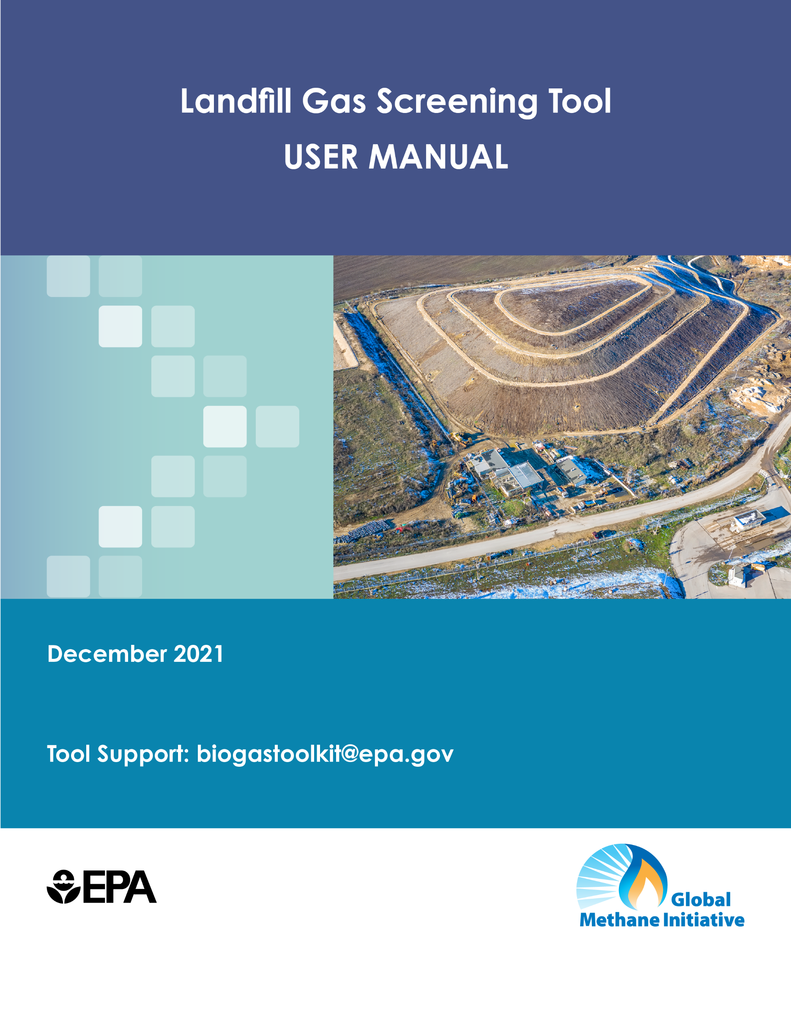

Landfill Gas Screening Tool
User Manual

Contents
Contents i
1. Overview 1
1.1 Organization of User Manual 1
1.2 LFG Screening Tool History 1
1.3 Organization of Spreadsheet Tool 2
1.4 Entering Data 2
2. Using LFG-Screening Tool Tab-by-Tab Guide 2
2.1 Basic Information 2
2.1.1 Cover 2
2.1.2 Introduction 2
2.1.3 Instructions 3
2.2 Waste Inputs & Landfill Category Assumptions 3
2.2.1 Waste Inputs 3
2.2.2 Landfill Category Table 4
2.3 Results and Next Steps 6
2.3.1 Results 6
2.3.2 Next Steps 6
3. Methodology, Assumptions, & Limitations 7
3.1.1 Methodology 7
3.1.2 Assumptions 11
3.1.3 Data Limitations and Uncertainty 11

Overview

Organization of User Manual
This User Manual accompanies Version 3 of the Landfill Gas Screening Tool (LFG) Screening Tool, or the tool). LFG-ST was developed by the U.S. Environmental Protection Agency under the auspices of the Global Methane Initiative and in support of the Climate and Clean Air Coalition. EPA managed the tool’s development with technical support from Abt Associates and SCS Engineers. The Microsoft-Excel tool assists users in determining the potential feasibility of a landfill gas energy (LFGE) project. The feasibility assessment is based on computation of estimated LFGE potential of a given site and subsequent analysis of whether the LFGE supply is sufficient for sustained operation of an LFGE project.

Primarily aimed at assisting the decision-making process in cities, the LFG Screening Tool offers a first-tier assessment of LFGE potential and project opportunities that may exist in a site. The tool is not meant to perform rigorous feasibility analysis. Other resources from the Global Methane Initiative (GMI) such as the International Best Practices Guide for LFGE Projects, landfill gas modeling and cost estimation tools may be better suited to perform more detailed assessments.

This manual contains:
- An overview of the tool and its design (Section 1),
- Detailed documentation on how to use the tool and interpret results (Section 2), and
- Explanation of the tool’s methodology, assumptions, and limitations (Section 3).

LFG Screening Tool History
As of October 2021, there have been three versions of the tool. The following list briefly describes the tool’s history and explains the differences between the different versions.

Landfill Gas Project Screening Tool (LFG-PST) 1.0 (2016)
- Developed and released after an initial scoping and needs assessment in 2016

LFG-PST 2.0 (2017)
- Released to the public
- Bug-fixes in Excel spreadsheet implementation

LFG Screening Tool 3.0 (December 2021)
- Re-named to LFG Screening Tool
- Development of a revised version of the tool updates, including the following:
  - Updated parameter values and assumptions,
  - Added Python-based automation to generate an extensive set of scenarios for exploration of multiple input parameters, and
  - Updated documentation to include revised assumptions and parameter lists.

Organization of Spreadsheet Tool
LFG Screening Tool’s eight tabs are categorized into three sections in the User Manual.

Basic Information
- Cover Page
- Introduction
- Instructions

Inputs and Assumptions
- Waste Inputs
- Landfill Category Table

Results and Next Steps
- Results
- Project Types
- Next Steps

Entering Data
The tool requires five data inputs about the disposal sites. Ensure you have the necessary disposal site and energy needs data before proceeding with the tool.

On the Waste Inputs tab, enter data for the disposal site into all blue (█) cells in the User Inputs column. Entering data into the blue (█) cells in the Notes and Sources column is optional.

The Results tab provides an estimated landfill gas recovery rate for the site parameters. In addition to assessing the landfill gas potential from your current disposal site, LFG Screening Tool allows you to explore alternative scenarios based on your energy needs.

Specific instructions for entering data into each tab can be found in the sections below.

Using LFG-Screening Tool Tab-by-Tab Guide

Basic Information

Cover
The Cover tab includes attribution and contact information.

Introduction
The Introduction tab contains a few paragraphs briefly describing the LFG Screening Tool’s usefulness to cities in assessing potential feasibility of an LFGE project. This tab provides key assumptions used in the tool. See the Methodology, Assumptions, & Limitations Section of this User Manual for more information.

Instructions
The Instructions tab includes high level instructions for how to run the LFG Screening Tool. instructions and tips are found on the Waste Inputs data entry tab.

Waste Inputs & Landfill Category Assumptions

Waste Inputs
This tab consists of the following:
- Waste Data table
- Landfill Category table
- Clear Inputs button
- Navigation bar, on the right side of the tab

After entering the five required data points into the blue (█) cells of the Waste Data table, navigate to the Results tab to see the output.

Waste Data table
In the Waste Data table, enter the five data points about your disposal site, listed below, required to run the screening analysis. The user should enter these data points in the blue (█) cells. Note that the tool is set up to run an analysis on a single disposal site. To analyze multiple sites, save separate versions of the tool and enter single site data into each separate version of the tool.

The table also provides a "Notes & Sources" column, to write in information about the source of their data, and any assumptions used. However, adding documentation is not required to generate results.

- Opening Year of Disposal Site
  - Write in numerical value.
- Closing Year (Actual or Projected)
  - Write in numerical value, either actual or projected.
- Annual Disposal Rate (Metric Tons/Year)
  - Enter numerical value in metric tons per year.
- Climate
  - Select from dropdown list of Very Wet, Moderately Wet, Wet, Moderately Dry, or Dry.
- Landfill Category
  - Select from dropdown list of 0,1, 2, or 3. Each number corresponds to a Landfill Category, which is further defined in the Landfill Category table section below.
    - Select 0 for Dump Site.
    - Select 1 for Open Dump.
    - Select 2 for Controlled Dump/Landfill.
    - Select 3 for Engineered or Sanitary Landfill.

After entering data for all five waste inputs, navigate to the Results tab using the hyperlink “Next Steps: View Results” link at the bottom of the Waste Input table.

Landfill Category Table
The Landfill Category table, replicated below in Table 1, provides characteristics of landfill types to assist users in selecting the appropriate disposal site category. The table provides definitions of landfill categories to assist users in selecting the appropriate waste disposal site type. As noted in the International Best Practices Guide for LFGE Projects, there is a direct relationship between the type and condition of a disposal site and the amount of LFG that could be collected from the site.

Table 1. Comparison of Solid Waste Disposal Site Types
Factor | Open Dump | Controlled Landfill/Dump | Sanitary Landfill
Environmental Factors
Atmosphere
Fires | Intentional burning common | Limited, may be present | Unlikely
Release of hazardous gases | Yes, if no collection exists | Yes, if no collection exists | Yes, if no collection exists
LFG collection and control | Possible, poor collection  efficiency expected | Likely, collection efficiency will depend on site conditions | Likely
Unpleasant odors | Yes | Possible, depending on site conditions and whether LFG is uncontrolled | Minimal, if the right  measures are taken to cover waste and control LFG
Ground/Soil
Topographical modification | Yes | Yes | Yes
Contamination (leachate) | Yes | Possible, depending on base or liner conditions | No
Gas migration | Yes | Possible, depending on site conditions | No
Water (Surface and Ground Water)
Channeling runoff | No | Possible, depending on site conditions | Yes
Contamination | Likely underground and surface water | Possible if low-permeability liners are not used | Minimal
Monitoring system present | No | No | Yes
Flora
Vegetative cover alteration | Yes | Yes | Yes
Fauna
Changes in diversity | Likely | Yes | No
Vector control | No | Potentially, depending on site conditions | No
Socioeconomic Factors
Landscape
Alteration of Condition | Yes | Yes, can be mitigated with visual buffer (for example, a forest buffer) | Yes, can be mitigated with visual buffer (for example, a forest buffer)
Humans
Health hazards | Yes | Potentially, depending on site conditions | Potentially, depending on site conditions
Negative image | Yes | Yes | Yes, improved if there is post-closure utilization of land
Environmental education | No | Yes, in some cases | Yes, with careful planning
Economics
Decline of land value | Yes | Yes | Yes
Formal employment | No | Yes | Yes
Changes in land use | Yes | Yes | Yes
Social
Waste pickers | Yes | Yes, in some cases | No
Source: International Best Practices Guide for LFGE Projects – 2012, Chapter 2, Solid Waste Disposal Site Design and Operational Considerations, Table 2.1, http://globalmethane.org/documents/toolsres_lfg_IBPGch2.pdf

Results and Next Steps

Results
After entering data into the Waste Inputs tab, navigate to the Results tab to see the following outputs.

The first table on the Results tab shows the following LFG outputs:
- Estimated LFG recovery rate – the tool applies waste disposal and other site data provided by the user to generate an estimate of the amount of LFG that may be available for recovery, in cubic meters per hour (m³/h).
- The number of years post-2021 that the LFG recovery will remain above specific gas flow rate thresholds associated with project types:
  - Number of years of gas recovery at a rate greater than 600 m³/h,
  - Number of years of gas recovery at a rate greater than 200 m³/h, and
  - Number of years of gas recovery at a rate greater than 50 m³/h.
The second table on the Results tab shows the Preliminary Project Feasibility Assessment:
- Preliminary project feasibility assessment – In Cell B16 the tool provides a qualitative statement of likely feasibility, such as, “Multiple project types and sizes may be feasible at this site,” or “No project likely feasible at this site. Based on user input data, projected LFG recovery rates are insufficient to support a project.”
- Project type and size options – In Cell B17, based on the estimated LFG recovery rate and number of years, the tool suggests project types and size options. For example, if there is enough gas for a small LFGE project but not a large project, the tool would report that “The recoverable amount of LFG is likely not sufficient for a 1 MW electricity generation project or 600 m³/h direct use project, but likely sufficient for a small (200 m³/h) direct use project or at least one very small (50 m³/h) direct use project.”
Navigate to the Project Types tab using the hyperlink “Next Steps: Consider Potential Applications” link at the bottom of the Results tab.

Project Types
Based on the project type and size options determined on the Results tab in Cell B17, the table on the Project Types tab provides examples of applications based on the project size. Cell B6 repeats the potential project types from the Results tab for easy comparison to the table below.
If project types are feasible at the site, navigate to the Next Steps tab using the hyperlink “Next Steps” at the bottom of the Project Types tab.

Next Steps
If the tool results suggest that a disposal site may be a promising candidate for a LFGE project, the next steps would be to conduct a detailed project assessment to estimate the quantity of LFG that it could expect to produce, followed by a feasibility analysis, if appropriate.

- Project Screening: The tool supports the first step, which is to identify a potentially feasible site for a LFGE project and inform stakeholders about what type of project may be possible (e.g., direct use or electricity generation). If the results from using this tool indicate a site has conditions that are favorable to support an LFGE project, users should proceed to Step II – Project Assessment.
- Project Assessment: If preliminary screening suggests that the recoverable amount of LFG may be sufficient for a LFGE project, the next step is to conduct a detailed assessment of the potential amount of landfill methane available for a project, what types of projects should be considered, the types and sizes of facilities required for such projects, and typical project costs. For this step, stakeholders may refer to the GMI’s International Best Practices Guide for LFGE Projects, and other tools and resources (e.g., landfill gas modeling and cost estimation tools available through the GMI). In addition, assessments generally require site visits and the specialized knowledge of LFG professionals. GMI may be able to provide support to cities in planning these activities, including finding expert assistance.
  - GMI’s International Best Practices Guide for Landfill Gas Energy Projects: http://globalmethane.org/sectors/technicalgroup.aspx?s=msw
- Feasibility Analysis: If a Project Assessment reaffirms that the site will generate a large enough quantity of gas to support an LFGE project, then the next step would be a detailed evaluation of the technical and financial feasibility of the project. Technical experts evaluate a project’s financial feasibility through an assessment of methane fuel availability, project revenues, and facility capital and operating costs, and present the results to potential project partners and investors. The GMI supports cities in identifying the key steps in conducting a feasibility analysis, including finding expert assistance.

Methodology, Assumptions, & Limitations

Methodology

LFG Output Methodology
The LFG Screening Tool estimates the amount of LFG potentially available to fuel energy projects and uses these estimates and user-identified energy needs to assess the likely feasibility of LFGE project types and sizes. The tool calculates the number of years that projects could be supported based on projected LFG recovery rates at three key thresholds: 600, 200, and 50 m³/h of LFG at 50 percent methane.

In Row 10, the tool calculates an estimate LFG recovery rate in m³/h based on the five data points entered on the Waste Inputs tab.

In Rows 11, 12, and 13, the tool calculates the number of years that projects could be supported based on projected LFG recovery rates at three key thresholds: 600, 200, and 50 m³/h of LFG at 50 percent methane.

Preliminary Project Feasibility Assessment Methodology
In Row 16, the tool indicates if multiple projects, a single project, or no projects are feasible at the site based on the estimated LFG Recovery Rate and Number of Years of LFG Recovery.
- Multiple project types and sizes may be feasible at this site: if the years of recovery calculations show that there are more than 15 years of fuel supply above the threshold required for a particular project (e.g., 600 m³/h for an electricity generation project).
  - Calculation Parameters:
    - All rate of recovery estimates greater than or equal to 15 years.
    - Between 7 and 15 years of LFG recovery at 600 m³/h AND greater than or equal to 15 years of LFG recovery at 200 and 50 m³/h.
    - Less than 7 years of LFG recovery at 600 m³/h AND greater than or equal to 15 years of LFG recovery at 200 and 50 m³/h.
    - Less than 7 years of LFG recovery at 600 m³/h, between 7 and 15 years of LFG recovery at 200 m³/h, AND greater than or equal to 15 years of LFG recovery for 50 m³/h.
- Only a single project may be feasible at this site: if calculations show that the landfill will generate 7 to 15 years of adequate fuel supply.
  - Specific Calculation Parameters:
    - Less than 7 years of LFG recovery at 600 and 200 m³/h AND greater than or equal to 7 years of LFG recovery at 50 m³/h.
- No project likely feasible at this site: if calculations show that the projected amount of time with adequate fuel supply is less than 7 years for any recovery rate.

In Row 17, the tool indicates the type of projects and sizes that may be feasible at the site. Table 2 summarizes the logic upon which this assessment of applicable project types and sizes is based. It shows the LFG recovery rate thresholds that must be met for a project of a particular type and size to be potentially feasible.

Project Example Methodology
Using your site’s recoverable LFG results and user-identified onsite or nearby energy needs, the tool generates examples of applications based on estimated project size. Table 3 presents a summary of these project-type examples.

Table 2. Tool Logic Used in Preliminary Project Feasibility Assessment
# Years > 600 m³/h | # Years > 200 m³/h | # Years > 50 m³/h | Preliminary Project Feasibility Assessment
>=15 | >=15 | >=15 | Recoverable amount of LFG likely sufficient for a 1 MW electricity generation project or 600 m³/h direct use project.
>=7 and <15 | >=15 | >=15 | Recoverable amount of LFG may be sufficient for a 1 MW electricity generation project or 600 m³/h direct use project, and likely sufficient for a smaller (200 m³/h) direct use project.
<7 | >=15 | >=15 | Recoverable amount of LFG likely not sufficient for a 1 MW electricity generation project or 600 m³/h direct use project, but likely sufficient for a smaller (200 m³/h) direct use project.
<7 | >=7 and <15 | >=15 | Recoverable amount of LFG likely not sufficient for a 1 MW electricity generation project or 600 m³/h direct use project, but may be sufficient for a smaller (200 m³/h) direct use project, and likely sufficient for a very small (50 m³/h) direct use project.
<7 | <7 | >=15 | Recoverable amount of LFG likely not sufficient for a 1 MW electricity generation project or a small (200 m³/h) direct use project, but likely sufficient for a very small (50 m³/h) direct use project.
<7 | <7 | >=7 and <15 | Recoverable amount of LFG likely not sufficient for a 1 MW electricity generation project or a small (200 m³/h) direct use project, but may be sufficient for a very small (50 m³/h) direct use project.
<7 | <7 | <7 | Recoverable amount of LFG likely not sufficient for an LFGE project of any size.
Notes: greater than (>); less than (<); greater than or equal to (>=).

Table 3. Examples of Potentially Feasible Projects Based on Recoverable LFG and Energy Needs
Project Type Based on  Recoverable LFG Results | Project Examples Based on Size of Project
Electricity Project | - Internal combustion engine (1 MW or greater)  - Gas Turbine (3 MW or greater)
Direct Use Project (600 m³/h) | - Pipeline to nearby industry with boiler  - Pipeline to nearby industry with direct thermal needs such as industrial dryers or kilns  - CNG vehicle fuel
Small (200 m³/h) Direct Use Project | - CNG vehicle fuel  - Industrial boiler at adjacent property  - Industrial kiln or dryer at adjacent property  - Greenhouse at adjacent property
Very Small (50 m³/h) Direct Use Project | - Small dryer  - Kiln or glassblowing (e.g., artist studio)  - Greenhouse, or other small thermal application  - Community hot water  - Community cook stoves
Note: Greater recoverable gas supply enables larger projects at potentially greater distances from the waste disposal site. For example, for the largest sized direct use project (600 m³/h), the LFGE project could be installed at a property adjacent to or within 2 kilometers from the waste disposal site. However, if the recoverable LFG supply is 200 m³/h or less, the LFGE project may need to be installed on site or at an adjacent facility that shares a property line.

Assumptions
Number of years post-2021 of LFG recovery. The tool calculates the number of years that projects could be supported based on projected LFG recovery rates at three key thresholds: 600, 200, and 50 m³/h of LFG at 50 percent methane. The results are based on the assumption that a project is “likely possible” if the calculations show that there are more than 15 years of fuel supply above the threshold required for a particular project (e.g., 600 m³/h for an electricity generation project). The tool will report that a project “may be possible” if calculations show that the landfill will generate 7 to 15 years of adequate fuel supply; or “not possible” if calculations show that the projected amount of time with adequate fuel supply is less than 7 years.

Waste disposal scenario modeling as basis for LFG recovery rates. The LFG Screening Tool scenarios have been developed based on outputs from various combinations of inputs provided to the Colombia Landfill Gas Model. Various combinations of starting and ending years, climate category, annual disposal rate, and landfill type are used to generate individual scenarios. The xlwings library of the Python scripting language has been leveraged to generate a procedure that automated the scenario generation process: the list of scenarios were uploaded to the Python environment that sequentially executed and extracted outputs from the Colombia Landfill Gas Model based on the set of inputs corresponding to individual scenarios.

Data Limitations and Uncertainty
The tool provides solid waste planners with an initial estimate of LFGE project potential. The tool’s results should be considered approximate. Tool results tell users whether there is potentially enough LFG for a small or medium-sized LFGE project and, if there is, it recommends conducting a detailed assessment of project potential.
As with any model, there is scientific uncertainty, model uncertainty, and parameter uncertainty involved in generating these outputs. The tool produces results that are subject to significant uncertainty and potential inaccuracies due to the limitations imposed by the tool’s structure and methods.
Limitations on data inputs/data error. The tool was designed to function using only the minimum amount of data needed to develop waste disposal histories and run an LFG generation model. Therefore, the results are less precise than what could be produced using a model that incorporates detailed site-specific data. Running a model with fewer data inputs decreases the likelihood of data errors but increases the impact of errors that do occur. For example, an inaccurate forecast for a site’s closure date in the near future has a high likelihood of producing significant error in the model results. To limit data input requirements, the tool relies on several default assumptions for key data items, such as disposal growth rates and waste composition. These default assumptions could be a large potential source of estimation error.
Limitations on the number of scenarios considered and outputs offered. To constrain the number of scenarios that had to be modeled to generate the tool’s outputs, the developers grouped a wide range of data inputs into a limited number of categories. In addition, the outputs the tool provides are limited to a set of nine possible results, including three possible outcomes for each of three project sizes. These limitations negatively impact the precision of the tool’s estimates and its accuracy for sites with conditions that are outside of the ranges considered in its development.
Uncertainty regarding the tool’s default assumptions used in LFG generation and recovery calculations. Without direct measurements of LFG generation in the field, it is not possible to validate LFG generation estimates produced using models such as the Colombia Landfill Gas Model. The Colombia Model applies default estimates for waste decay rates (k) and methane productivity (Lo) of different waste materials that were developed using information published by the IPCC and measured LFG flows from two sites in Colombia. The model k and Lo values and other model variables may or may not accurately reflect the effects of climate, site conditions, and the ability of organic waste to degrade and produce LFG at the disposal site being evaluated. In addition, the LFG collection efficiency assumptions used to produce LFG recovery estimates are approximate, at best, and can cause large estimation error.

Global Methane Initiative. International Best Practices Guide for LFGE Projects – 2012, https://globalmethane.org.
For purposes of scenario generation, value of collection efficiency input to the Colombia Landfill Gas Model depends upon the landfill type.

