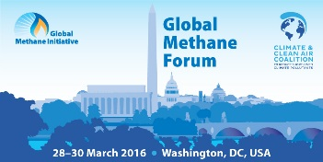

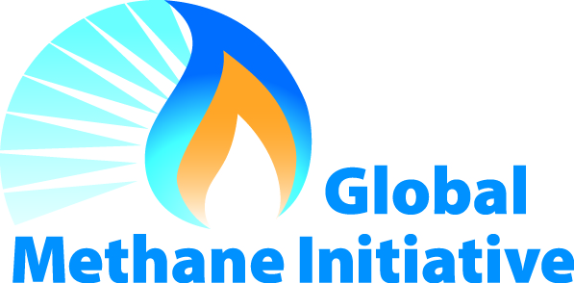
23 June 2015

Dear Potential Supporter:

Thank you for your interest in supporting the Global Methane Initiative’s (GMI) Global Methane Forum scheduled to be held the Georgetown University Hotel and Conference Center in Washington, DC, USA on 28-30 March 2016. GMI is organizing the Forum in partnership with the Climate and Clean Air Coalition (CCAC). CCAC will also hold its two-day Working Group meeting at the same venue on 31 March – 1 April. This one-of-a-kind event is the perfect opportunity to learn about methane abatement and reduction related activities and engage with experts from around the world. Participants will hear first-hand about the latest technologies and successful case studies in the following sectors: biogas (agricultural sources, municipal solid waste, municipal wastewater systems), coal mines, and oil and natural gas systems, as well as cross cutting issues.

This letter outlines options and opportunities to provide financial support for the Forum.

Support Opportunities

Due to government regulations, we are unable to use contract funds to cover the costs of food and beverage served at the Forum. We rely on the generosity of our supporters to make the Forum one of the most anticipated events of the year! Your generosity allows us to provide our attendees with top of the line food and beverage, as well as valuable networking receptions. All funds provided by our supporters will be used to augment the refreshments served during the forum. Supporters will enjoy a host of benefits, including increased exposure among attendees and recognition in the handout materials. We will list supporters in the Forum proceedings, the agenda, and will post signs acknowledging supporters’ generous donations. Signs will include single color graphics (i.e., logos) if they are provided electronically in advance.

There are two ways to support the Global Methane Forum:
- Option One: Provide support at a certain dollar level.
- Option Two: Be a primary supporter of a specific event function.
These options are outlined in detail on the attached Supporter Opportunities form.

If you are interested in any of these opportunities please fill out the enclosed forms and fax them to the ASG's contractor, Eastern Research Group, Inc. (ERG), at 781-674-2906 (fax) or email them to asg@globalmethane.org. A conference planner from ERG will call you within a few days to coordinate your supporter options and/or confirm your exhibit space. If you have any questions please feel free to contact ERG at 781-674-7272 (phone), or via e-mail: asg@globalmethane.org.

Thank you for your interest supporting the Global Methane Forum. We look forward to seeing you in March in Washington, D.C.!

Sincerely,
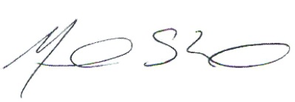
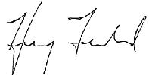

Henry Ferland and Monica Shimamura
Directors, Administrative Support Group
Global Methane Initiative

Global Methane Forum
SUPPORTER OPPORTUNITIES

Supporter Commitment Form

There are two ways to support the Global Methane Forum:

Option One:  Provide support at a certain level (Platinum, Gold, Silver, or Bronze); funds will be used to augment the food and beverage served at the conference. See next page for a description of benefits for each level.  I am interested in being a Global Methane Forum Supporter at the following level:  Platinum Level = $5,000  Gold Level = $3,000  Silver Level = $2,000  Bronze Level = $1,000 |  |  | Option Two:  Be a primary Supporter for a particular reception, breakfast or lunch. There are a variety of options available listed on page 4. Opportunities to be a primary Supporter for a specific function are limited and will be allotted on a first come, first assigned basis. If your first option is not available, ERG will contact you to discuss other available options.  Yes, I would like to be a primary Supporter and I have indicated my preference in the box below

Please fill out the following contact information; this will be used to coordinate your support options.

NAME:

COMPANY NAME:

ADDRESS:

PHONE:

FAX:

E-MAIL:

Submit the completed form via email: asg@globalmethane.org or fax: 781-674-2906.

Global Methane Forum
SUPPORTER OPPORTUNITIES

Description of Option One: General Supporter Benefits

Category | PLATINUM SUPPORTERS | GOLD SUPPORTERS
Online Advertising | - Link to your website from the Forum’s homepage.  - Link to your website from the Forum’s supporter page.  - Company/project portrait on the Forum’s supporter page (max 200 words). | - Link to your website from the Forum’s supporter page.  - Company/project portrait on the Forum’s supporter page (max 100 words).
Forum  Program | - Your logo on the front page of the Forum program.  - Your logo on the Forum program’s supporter page. | - Your logo on the Forum program’s supporter page.
Signs | - 5 signs with your logo will be on display at the Forum. | - 3 signs with your logo will be displayed at the Forum.
Extras | - 1 electronic copy of the attendee list with contact information. | - None
Package Fee | $5,000 USD | $3,000 USD
Category | SILVER SUPPORTER | BRONZE SUPPORTER
Online Advertising | - Link to your website from the Forum’s supporter page. | - None
Forum  Program | - Your logo on the Forum program’s supporter page. | - Your logo on the Forum program’s supporter page.
Signs | - 2 signs with your logo will be displayed the Forum. | - 1 sign with your logo will be displayed at the Forum.
Package Fee | $2,000 USD | $1,000 USD
Global Methane Forum
SUPPORTER OPPORTUNITIES

Description of Option Two: Event Support

The following is a list of available group functions that are planned for the Global Methane Forum and the costs associated with being a primary Supporter of the event.

Reception
Antipasto Display
Deluxe Hors d’Oeuvres
Meat Carving Stations
Pasta Station
Costs: $12,000, 2 available

Reception Bar
Only Full Sponsorship of the Bar Can Be Accepted.
Costs: $10,000, 2 available

Morning Refreshment Break

Assorted Fruit Juices
A Selection of Seasonal Cubed & Whole Fruits
Assorted Bagels with Cream Cheese
Fresh Bakery Selection to Include Muffins and Coffee Cakes
Freshly Brewed Regular & Decaffeinated Coffees, Variety of Traditional & Herbal Teas
Costs: $4,000 per day, 3 available

Buffet Lunch
Salads
Entrées
Chef’s choice vegetable and starch
Desserts
Regular & Diet Soft Drinks, Bottles of Flavored Iced Tea, Chilled Sparkling & Still Mineral Waters, Freshly Brewed Regular & Decaffeinated Coffees, Variety of Traditional & Herbal Teas
Costs: $8,000 per day, 2 available

Afternoon Break
Fruit bars, brownies, and blondies
Regular & Diet Soft Drinks, Freshly Brewed Regular & Decaffeinated Coffees, Variety of Traditional & Herbal Teas
Costs: $4,000 per day, 3 available

PLEASE NOTE: All menus are tentative and based on reception venue offerings. Menu items can be adjusted to fit Supporters’ requests, please contact ERG at 781-674-7272 for additional information.

